8.20

Where does your true advantage lie in? (perceived)

1. Automated trading
2. No emotions involved, no fatigue
3. Takes advantage of pmch reversal (statistically proven)
4. Delta risk is hedged
5. Only sell at highs, buy at lows. (percentileMATrader, intradayMA, firstTickAccu)
6. Hedge day hilos. (one direction is hedged, then the same direction cannot be traded again)
7. No chasing.
8. First tick on the index has predictive power on how the index goes during the day (perceived)

This week:

1. Keep tuning parameters, add weight to profitable strategies (last week, fut open, percentileMA was good. IntradayMA/profittaker was bad, china HiLo is good)
2. Last week the loss mainly came from intraday accumulation, these strategies are penalized.
3. Last wed’s futopen and firsttick were good orders. Thur’s hilo was good. Focus on these.
4. Pmch threshold changed to +-20 to avoid last Monday’s foolish accumulation.
5. Ftick MA can only happen if the first tick trade happened, and it cannot exceed the first tick size, and this type is being penalized due to bad performance.
6. intradayMA picks up too much units, being penalized (longer wait time)

Idiosyncratic risk is high with loss on one stock.

Yunnan Baiyao -10%. Others – no much impact.

Added index hilo accu, trade a few lots before 9:40 to catch sudden rises or drops in addition to opening china_hilo. Only at extreme percentiles.

PM:

1. intraday MA: pm buy: increase size. Reason is if there is a signal, this order has a big probability of success.

Market end:

1. trade pnl was 3000 on today’s trades (3 lots was by chinaHiLo, 1 lot by intradayMATrader). ChinaHiLo needs to have an accumulator, not all at once. IntradayMA trader increase size when buy signal in the PM.
2. now the delta target is -1.7mm, which will be taken care of by percentileMA

8.21

**Markets:**

* Markets insanely volatile, rocking downwards with huge volatility
* Avoid shorting too much on Tuesdays, it is still the strongest day
* Keep delta fuse at +- 2mm delta for safety reason

**Problems**

* Trading too much
* Distance between trades too short (60 minutes a minimum), now it is overtrading
* Not taking enough advantage of hilo, need more of high low reducing hedge.
* Work on opening reducing hedge.
* Shouldn’t keep shorting today when AM breaks new highs (but should not buy either, if you cover you will lose money in expectation)
* Either space trades out even more, or increase delta.
* All trades should have positive expectation at the same time, don’t take on too much risk. percMA sell size has to be reduced, short positions add up very quickly.
* Buying has a much higher statistical advantage with winning when prev < 0, compared with selling when prev > 0 (unclear).
* percentileMA selling -> not good. PercentileMA buying on lows -> good
* you have to bet less when pmch>0 (fixed MA sell size to 2)
* futopentrader: sell is good but need to cover hedge if index is very strong. Perc MA/intraday MA will short for you. Futopen has percentile and pmch requirements.
* Cover hedge through hilo.

Overall:

1. Volatility very high at the bottom
2. Hilo trading is important to capture all day rise/fall
3. Mon/tue strength cannot be underestimated
4. First tick was triggered because of wait time = 60.
5. buy and sell size needs to be asymmetric. For firstTickTrader: buy: +3 lots, sell:-1 lot, when pmchy is down, there is more advantage than when pmchy is up.

Problems with the current system:

1. cannot consistently make money
2. need to combine all the knowledge you have to make it work
3. weekday delta addition is important.
4. Currently uses 2 day percentile, now index continuation lasts longer than 2 days, you will buy early and sell early.
5. Net profit is negative cumulatively for the last two years, most profit was lost in Feb, these few months with hedge, it is getting better.
6. Market is getting more directional. Meaning your hilo really needs to work, it needs to work independently from the percentile.

**Corrections:**

* Tuesday strength is apparent
* don’t short too much on Tuesday even with advantage (tues morning add weekday delta to 1mm to discourage shorting) (done)
* pmchy, when negative, stay unchanged. When positive, reduce shorting size. (done)
* percentile MA size: when shorting, reduce to 2, when long, keep at 4.
* Avoid overtrading : min trade time is 60 minutes between trades

**Experiments:**

Experiment with hilo direction

8.22

09:29:59.456=11277.114462, 09:30:00.457=11275.989675,

First day using open deviation – didn’t work.

First tick didn't work because both pmchy and 2dp didn’t reach requirement.

Open deviation didn’t work because there was no direction change – the code is wrong.

Changes

1. Unconditional trading of first tick

8.23

Research on openDeviation

High vol environment: more potential for profits, less crosses.

Currently market is above 19v, so it is profitable to trade open deviation.

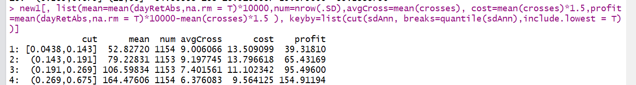

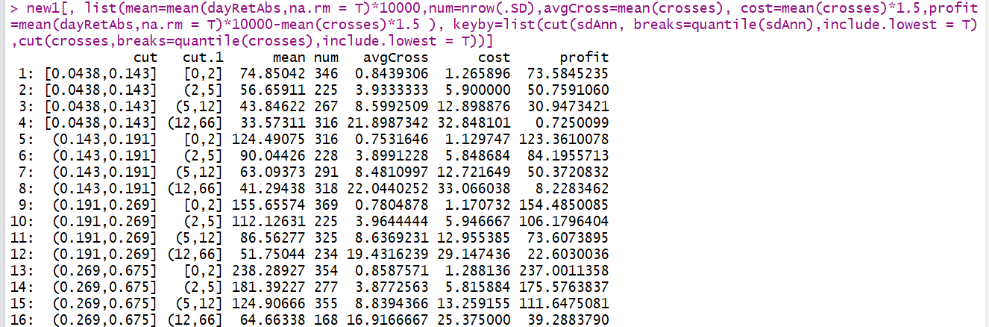

Shows vol/crosses and profits: limit total crosses to 5, (above 5 to 66, there isn’t much additional profit).

If you do 6 crosses, you are already covering 50% of the crosses case which yield the highest returns. If it goes above 6, then you want to give up on that day. 6 crosses will cost you 1.5 bps*6 = 10 bps for transaction cost. Each minute only 1 cross is allowed. You will also need to take into account the slippage if no trading is allowed that minute, especially at the open when things are volatile.

Following cases are profitable:

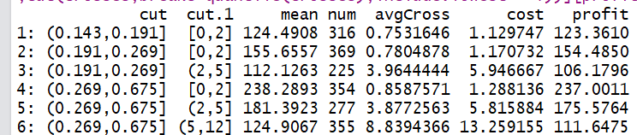

When vol is low, restrict to 2. When vol is high, go up to 10 lots. Now vol is at 20 ish.

So limit at 6 is fair. Make sure it is even number so it doesn't actually change your net delta.

When vol > 19v, quite safe to trade openDev. You need to cover a lot of slippage, in some cases over 50 bps.

1. Self cancelling – even times of trade. If trades too many times, ends on an even number.
2. Possible use of leverage.

After open:

09:30:00.974=11235.467664000002, 09:30:01.974=11234.345688000001,

**Open deviation:**

When index beats around the open, it is considered to be directionless and openDeviation should stop trading after 5~6 trades. In this case, let other trades do the job.

Vol is currently at 22v.

Beating around the open is what you don’t want.

One minute is too little.

After 3 sets of beatings, stop open deviation for the day. Note that the PD also costs you (especially on stale crosses, had to wait for 1min), then the prices are nowhere good.

During these days, trading doesn’t generate profits, on big up/down days it generates profits.

When markets are volatile that is when money is to be made.

When index frequently beats around the bush, it means there is no vol.

823 after market:

1. Processmain is based on fut price, but the real determinant should be index prices, check where prices are being updated and trade fut trade at source.
2. Migrated 3 traders to sinastock where data is being collected. Trade at source.
   1. order analysis:
3. open deviation executes slower than index change (because you were trading based on future price changes instead of index price change)
4. pm MA crosses -> allocate more size to them (to percMA and to intradayMAtrader)
5. perc ma/intraday ma didn’t get filled -> put addon 2.5 to guarantee fill
6. intraday MA needs to be migrated to sinastock, trade based on index, not futures
7. open deviation sucked today. There were too many crosses. Market was range bound. PercMA/intradayMA made most money. Also, open deviation didn’t trade at the first point of index change. Apparently, today was NOT directional and openDeviation should trade less as a result.
8. Dynamic adjustment of openDev: reduce size/cap orderSize to 6/increase trade time.
9. Design a system for automatic longer waiting time if

PercentileMA/all MA trades are short vol strategy, because it bets on reversal when markets are weak.

If vol explodes, then your strategy will lose money.

I want to be relatively hedge in all cases.

When vol explodes, openDeviationTrader/futOpenTrader will trade.

When vol subsides, MA will trade.

Different strategies reduce the overall riskiness, also it increases utility and reduces stress because you tend to make/lose in all scenarios, it is diversifying your stress away.

Currently vol is very high, so high-vol strategy such as openDeviation will be profitable.

8.24

First tick:

09:29:58.701=11196.493, **09:29:59.701=11195.369**

1393 open deviation sell T: 09:29:59.701 Order: 1393 SELL DAY LMT 1.0 at 11190.0 msg: Tradetype OPEN_DEVIATION Status: Created open/ft/last/openDevDir/vol 11196.49 11195.37 11195.37 IDX chg: -1.0E-4 fut pd 11190.0 -5.0E-4 Flat 0.2141

||Order|| 1393 101 T: 09:29:59.701 Order: 1393 SELL DAY LMT 1.0 at 11190.0 msg: Tradetype OPEN_DEVIATION Status: Filled Filled

Comments:

Open deviation didn’t waste time.

Firsttick didn’t trade due to 2d percentile.

Vol is around 20v.

Short position got knocked out **09:57:11.701=11197.617,** you lost on the PD moving flat, doesn’t cost anything, the timing is perfect.

1394 open deviation buy T: 09:57:11.701 Order: 1394 BUY DAY LMT 1.0 at 11197.5 msg: Tradetype OPEN_DEVIATION Status: Created open/ft/last/openDevDir/vol 11196.49 11195.37 11197.62 IDX chg: 1.0E-4 fut pd 11197.5 0.0 Short 0.2059

||Order|| 1394 102 T: 09:57:11.701 Order: 1394 BUY DAY LMT 1.0 at 11197.5 msg: Tradetype OPEN_DEVIATION Status: Filled Filled

When you sold, you sold at discount, when you bought, you bought at flat PD. Market is stronger as it is trying to advance.

1425pm:

Volatility is huge. Market got bid up very aggressively. Hedging is poor, banks/insurance went up while stock ptf underperformed.

There is government effort to pull up financial sector to pull up the index. The money is not going into any other sectors.

**Trading:**

Conservative trading when openDev >= 2, trendy markets don’t have frequent hits.

1,2 trades: can take some losses on PD, for speed.

3,5 trades: only take $2.5 losses, the risk is they may never get filled. (these are opening trades)

4,6 trades: trade at future price to ensure execution (these are closing trades).

Don’t want to pay any other cost (PD adds up, only first two trades can afford to trade future price)

Potential issue is trades don’t get done.

Markets are very volatile.

**Weekly analysis:**

This tue’s loss on the futs are not good. Put in open deviation to hedge against big rises.

Do you have a true advantage in this market even with quant trading?

Stocks:

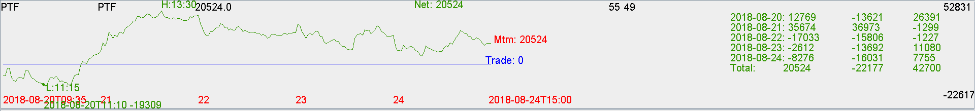

Futures:

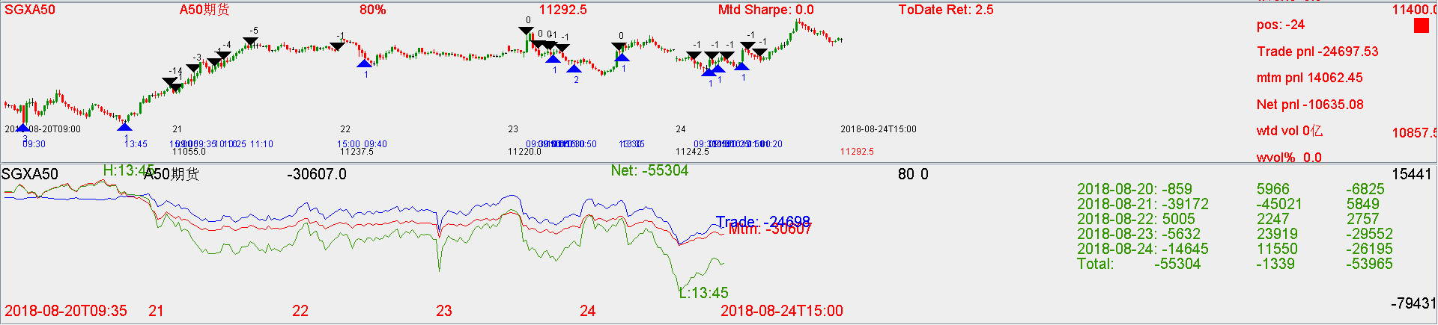

Bad trading on Tuesday: shorting too much rising market.

Market closed on the high of the week.

This week, market is up 4%. Last week it was down 5%.

Weekly vol is high.

Now 000016 flips bullish. Delta goes to flat.

Trading loses money every week – reason is vol is too high.

Your trading is NOT good enough to generate consistent returns.

There has to be modifications.

Biggest sources of pnl: delta pnl (not trading).

You are hedged well at the bottom, beating the index.

Keys:

1. Hedge market crashes like Feb.
2. Sizing on the hedge trades. Delta swings.
3. Hedge on/off scenario.